Project Design Phase

Problem – Solution Fit Template

Date | 15 February 2025
Team ID | LTVIP2026TMIDS41308
Project Name | Online payment fraud detection with machine learning
Maximum Marks | 2 Marks

Problem – Solution Fit Template:
Problem–Solution Fit means identifying a real problem faced by users and providing a solution that effectively solves that problem. In this project, online payment users face the problem of fraudulent transactions, and the proposed fraud detection system helps prevent and identify such frauds.
Purpose:
❑ To solve online payment fraud problems in a way that suits user behavior.
❑ To detect fraud quickly using existing platforms like banking apps and transaction systems.
❑ To improve user trust through timely alerts and accurate fraud detection.
❑ To increase interaction between users and banks by identifying risky transactions.
❑ To understand current fraud issues and improve security for online payment users.

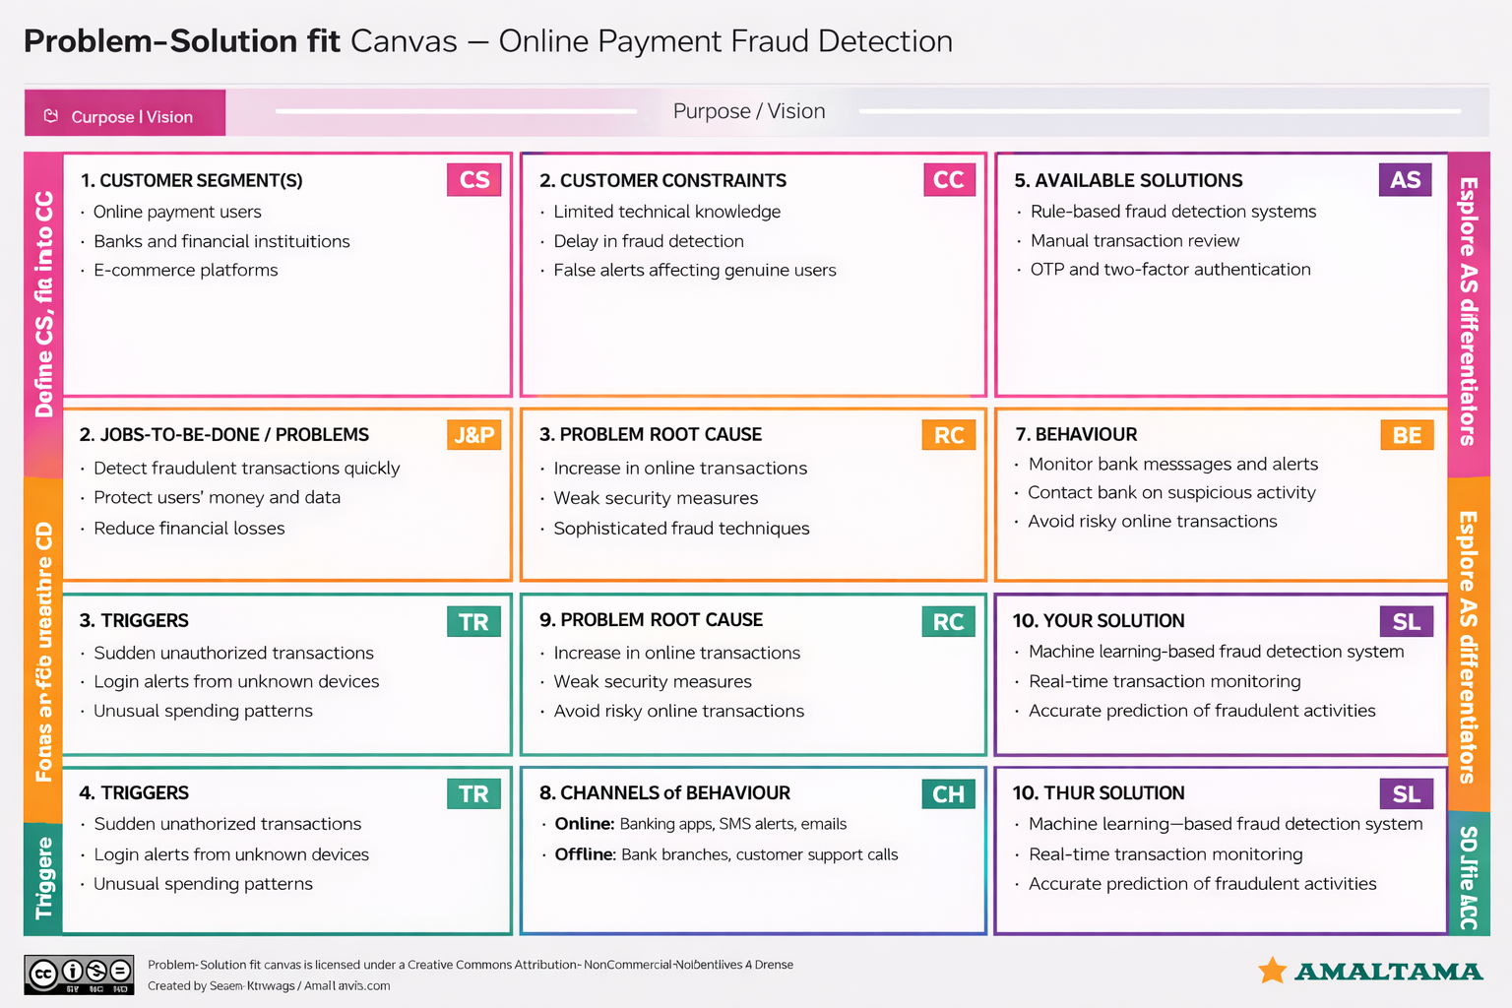
Template:

